1. create Sprints directory
2. create (music pictures and vid )
3. create 6 ordered files song1.mp3>>song 6 : snap.jpg1:6 : film1.avi>>6
4. move songs to music, films to vid , snaps to pic
5. create family directry inside sprints
6. copy movies to family
7. create friends directry inside sprints
8. mobe movis to frinds
9. type history and take screenshot

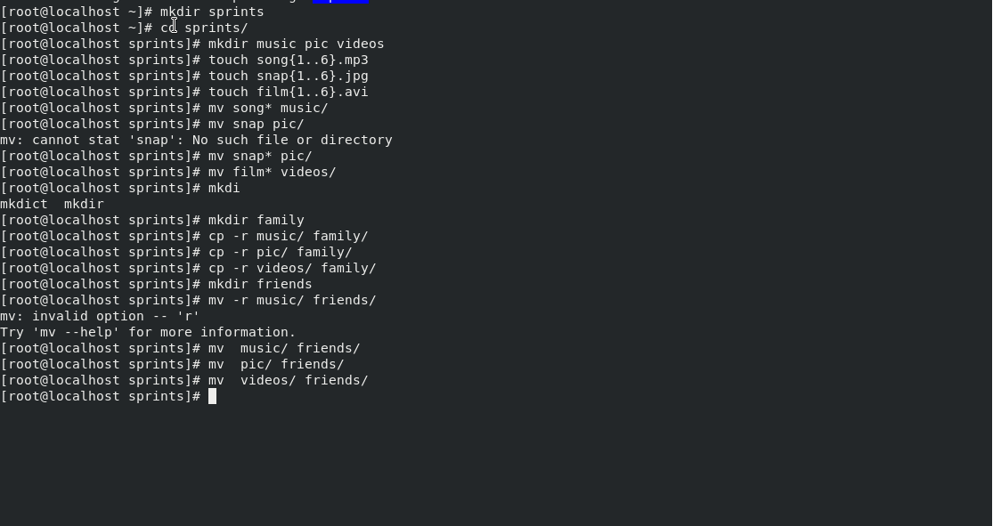

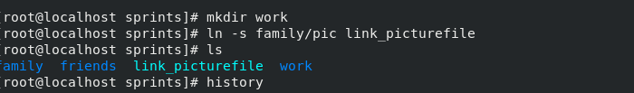

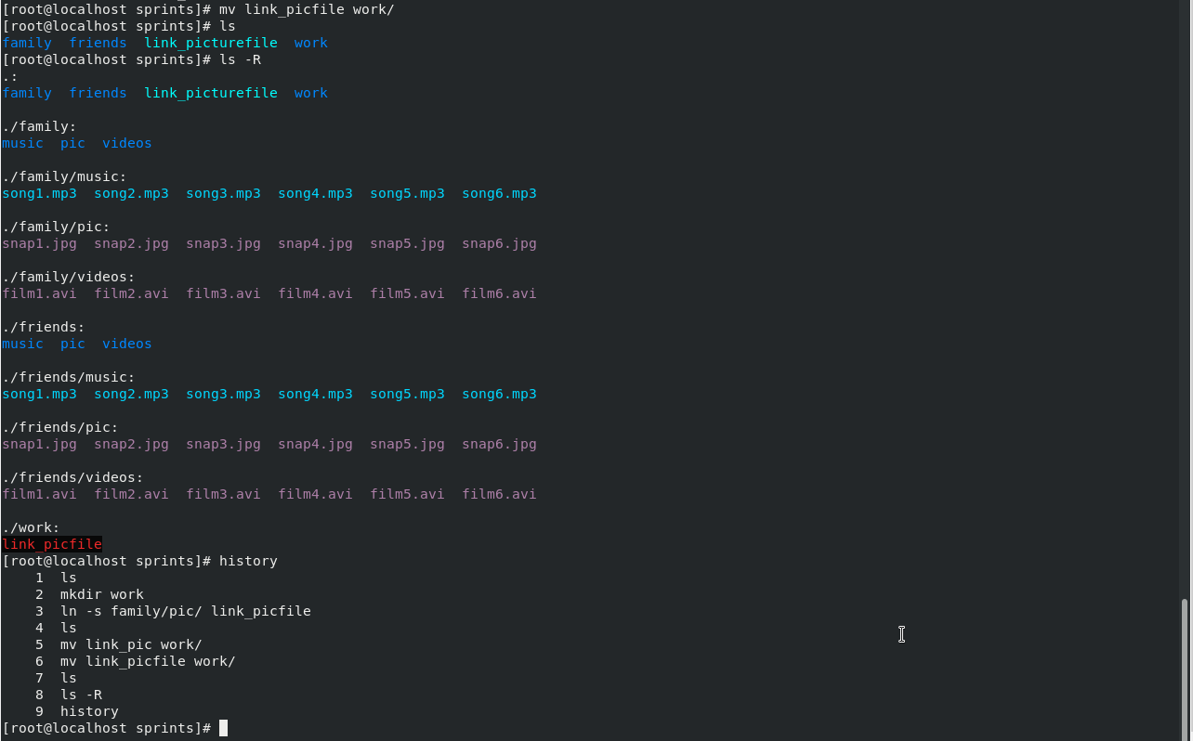

Task 3

